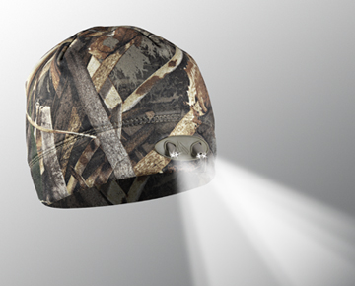
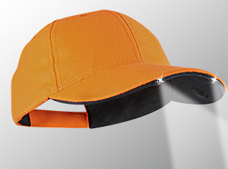
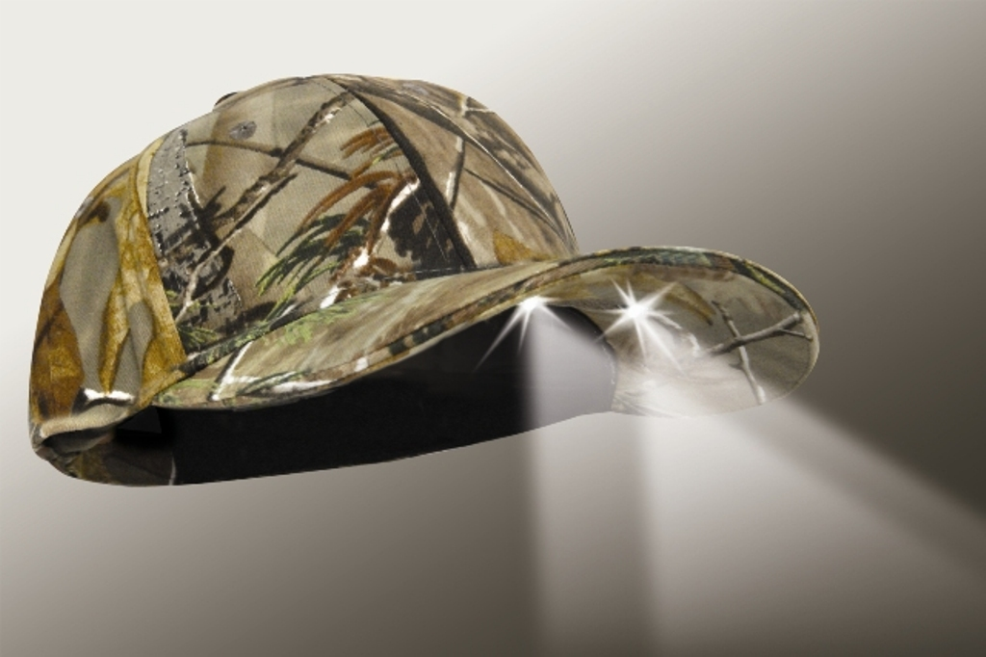
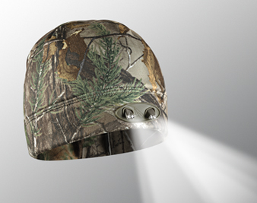
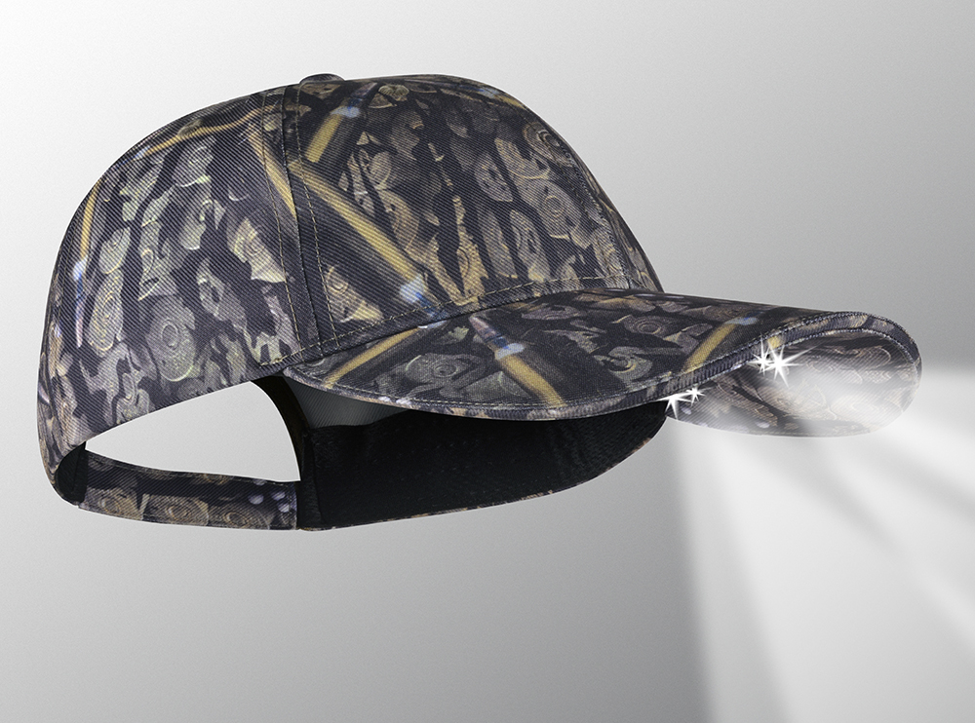
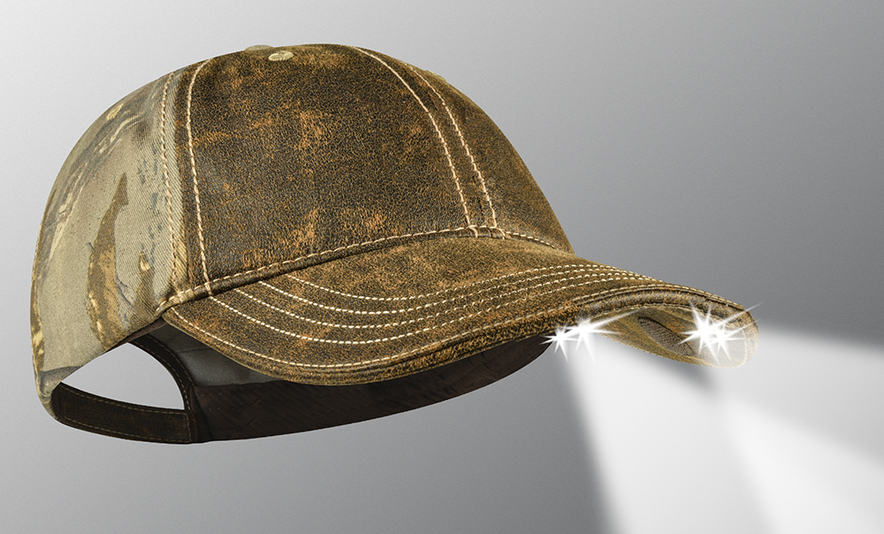
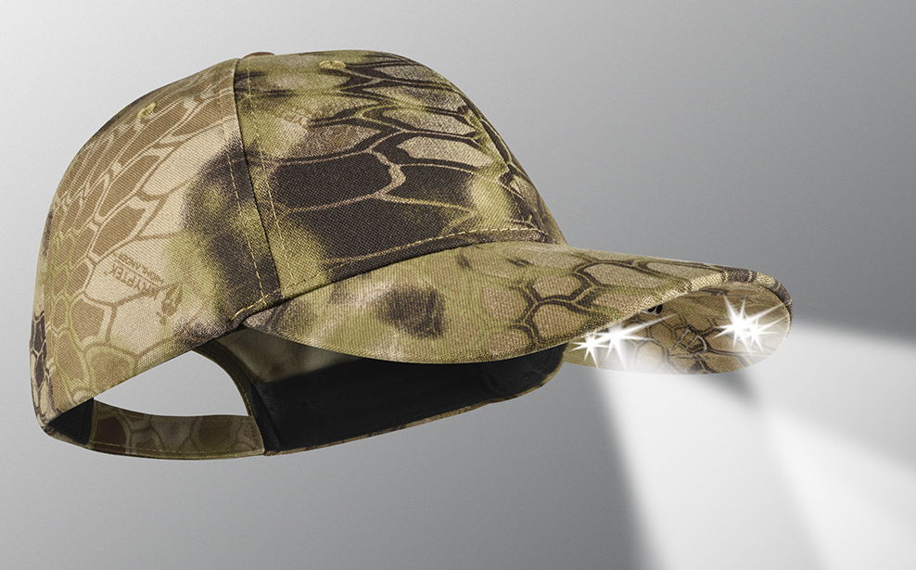
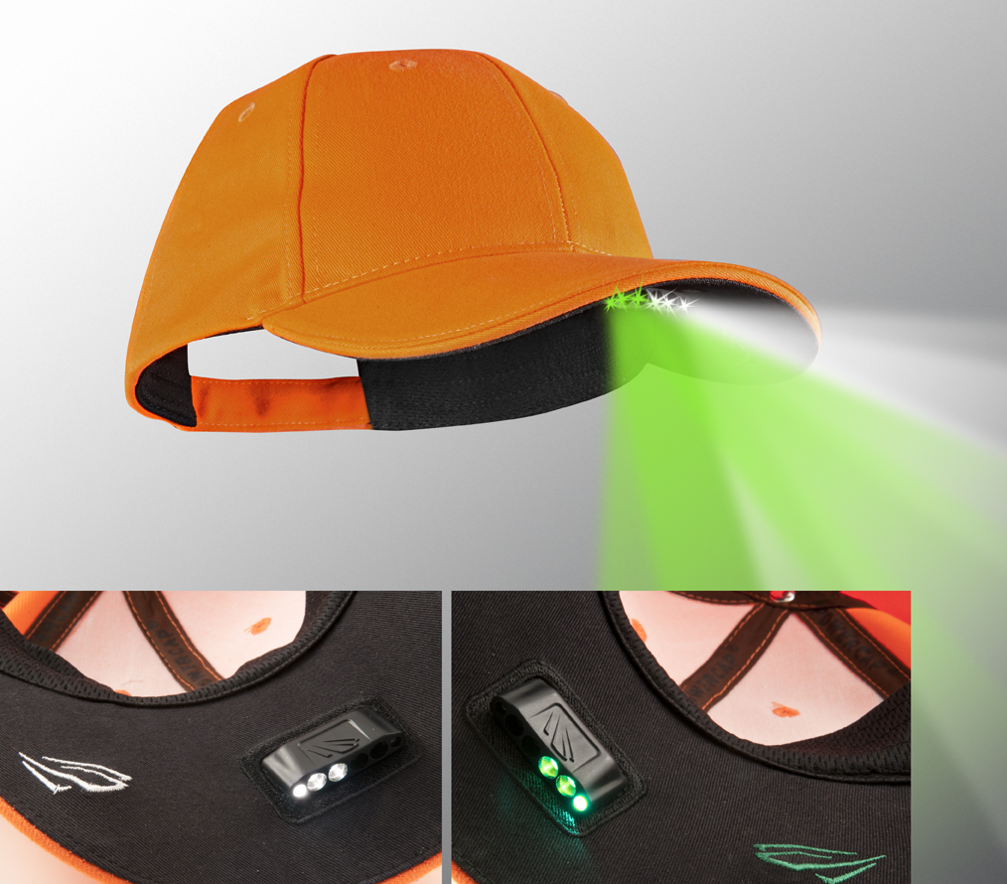
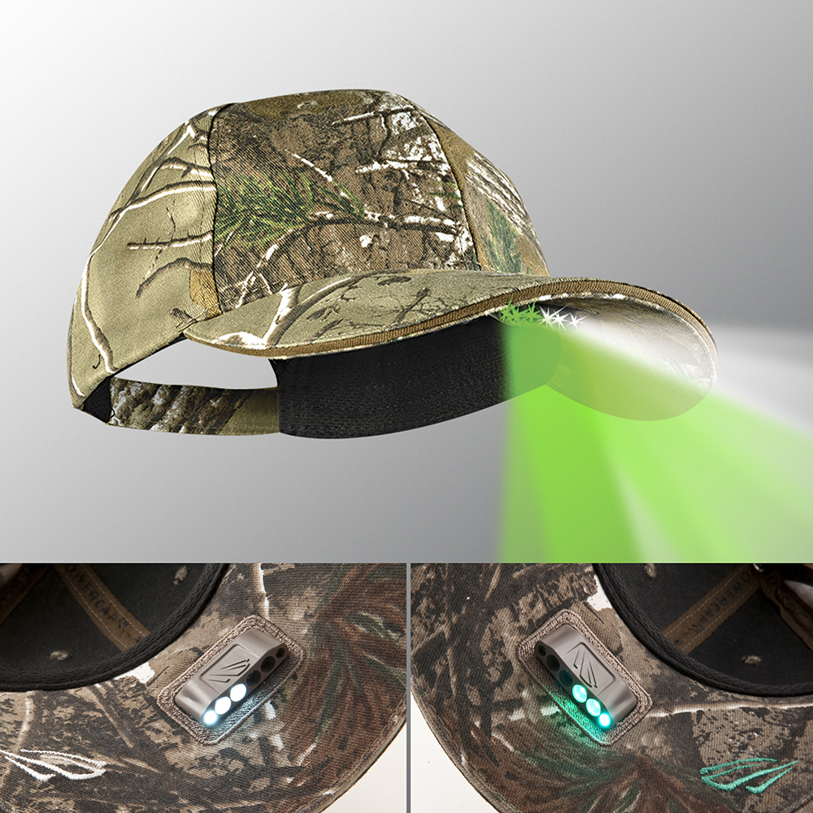
PS6-164 realtree xtra®
POWERCAP® nightvision

VISIT OUR WEBSITE WWW.PANTHERVISIONPROMO.COM
TO SEE THE FULL LINE OF LIGHTED PRODUCTS
OR CALL 847.783.5900 x 116 FOR MORE INFORMATION

Hunting for that
great fall promotion?

VISIT OUR WEBSITE WWW.PANTHERVISIONPROMO.COM
TO SEE THE FULL LINE OF LIGHTED PRODUCTS
OR CALL 847.783.5900 x 116 FOR MORE INFORMATION

VISIT OUR WEBSITE WWW.PANTHERVISIONPROMO.COM
TO SEE THE FULL LINE OF LIGHTED PRODUCTS
OR CALL 847.783.5900 x 116 FOR MORE INFORMATION

WB-4539 REALTREE Xtra®
Powercap® 3555 BEANIE
PS4-199 Ammo camo™
POWERCAP® Stealth 2575
PS4-7097 REALTREE® XTRA WITH faux leather front
POWERCAP® Stealth 2575
CL2-280032 Blaze orange
CAPLIGHT™ 2000

PS2-160 REALTREE Xtra®
POWERCAP™ Stealth 2500
WB-5659 REALTREE max 5®
Powercap® 3555 BEANIE
PS4-203 Kryptek® highlander
POWERCAP® Stealth 2575
Each style offers different color options
PS6-133 blaze orange
POWERCAP® nightvision
Whether setting up your tree stand before the sun comes up or tracking wounded prey as the sun sets, our hands-free lighted headwear will enhance your hunting experience.

For hunting safety or blending into nature, we have the top camo patterns and blaze orange options to suit your hunting preferences.

They look like a normal hat. Click the button and you have a high powered flashlight capable of 22 meters of forward lighting. Step up to the NightVision option with green LEDs for blood tracking and will not spook deer.

Add your logo to their most LOVED,
used and indispensable tool.
Use on the job and for play.

UNCOMMON LIGHTING TECHNOLOGY
FOR COMMON PROBLEMS!

Add your company
information and logo here
Amazing hunting hat

